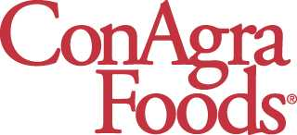

News Release
For more information, please contact:
Regina DeMars
(402) 595-6727
Regina.demars@conagrafoods.com
Jonah Ansell
(312) 228-6831
Jonah.ansell@ketchum.com
www.hebrewnational.com
www.conagrafoods.com

News From Our Brand
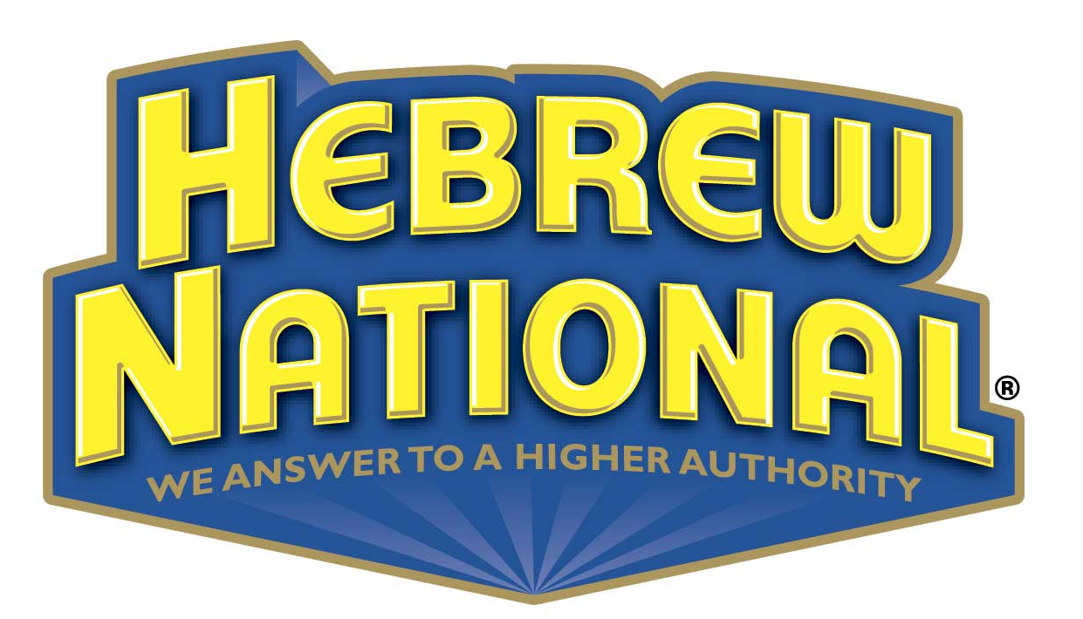

F O R I M M E D I A T E R E L E A S E

HUNGRY FANS TO JUDGE AS DETROIT TIGERS’ HOT DOG VENDORS CRY OUT FOR FIRST-EVER HEBREW NATIONAL ‘HIGHER AUTHORITY HAWKER’ TITLE
Hawkers display ballgame battle cries at Comerica Park, auditions footage to be released June 25; fans vote on favorites based on passion for hawking, creativity & overall technique; best hawker selected July 21

DETROIT, June 27, 2006—The old adage ‘When the cat is away the mouse is at play’ still rings true here in Detroit. With the first place Tigers’ on the road last week, Comerica Park wasn’t all quiet as the Tigers’ hot dog vendors strutted their stuff as they auditioned to be named Comerica’s top hot dog hawker. For Tigers fans hungry for a high-quality hot dog, Comerica Park’s hot dog hawkers are arguably as important as any pitcher on the field for getting a win, as they put their best stuff into selling and tossing hot dogs to famished fans to fuel the cheers that can carry the team to victory. Now, Tigers fans will get a chance to recognize and reward the skills of their favorite hot dog hawkers as they judge Hebrew National®’s first-ever “Higher Authority Hawker Challenge,” which will comb the stands at Comerica Park this summer to identify Detroit’s all-time best hot dog hawkers.

On Friday, June 16, Hebrew National’s “Higher Authority Hawker Challenge” commenced and the brand is seeking out those hawkers who stand out from the crowd and can show they’re the very best. The standard hawker cry, “get yer hot dog,” won’t be enough to get past the infield for first-place Detroit Tigers fans, nor will it cut the mustard for hawking premium Hebrew National franks, which are made from 100-percent, kosher-quality beef with no fillers. Hebrew National, where “kosher” means “quality,” is recruiting the highest-quality, most-outgoing and energetic hot dog hawkers to reward them for serving Detroit’s avid fans as they cheer on the AL Central-leading Tigers, who currently have the best win/loss percentage in Major League Baseball.

At Comerica Park, food hawkers will put on one “yell” of a competition to win the hearts and votes of Tigers fans, with their own distinctive hawking styles. In a nail-biting showdown that pairs passion with poise, hawkers will take to the stands to flaunt their best cries during an audition to become a finalist and member of the ‘Hawker Hall of Fame.’ On July 21, the Tigers’ best ‘Higher Authority Hawker’ will be selected in a finalist showdown during a pre-game ceremony at Comerica Park. Hebrew National will honor the winning hawker with a luxury trip to New York City to see the Tigers take on the Yankees, and Hebrew National will roll out the red carpet with a personal wait staff at Yankee Stadium. When the Tigers win, the night will be the hawker’s ultimate FAN-tasy.
“While the baseball players perform on the field, the food hawkers are in command in the stands,” said Jon Swadley, marketing manager, Hebrew National. “The ‘Higher Authority Hawker Challenge’ is a way for Hebrew National to salute those unsung baseball heroes who make our days at the park truly memorable.”

After the initial auditions, and for the duration of the program ending July 21, Hebrew National will roll out a ‘Higher Authority Hawker’ Voting Station located on the main concourse of Comerica Park, where during Tiger home games, fans can view the hawker audition tapes on a television monitor, submit votes for their favorite hawker and check back to view the current leaders. Upon voting for their favorite hawker, fans will be automatically enrolled for the chance to win a Hebrew National Prize pack consisting of free tickets to a future Detroit Tigers baseball game and coupons for free Hebrew National kosher franks. Even non-voting fans can upgrade their gameday experience by simply being spotted by Tigers’ staff eating a Hebrew National All-Beef Frank. If spotted, one Hebrew National-frank-eating fan will be selected to "Upgrade his or her Experience" with a prize package of an authentic jersey, hat and autographed baseball.

On June 27, the first hawker finalist will be announced based on audition performance and in-stadium fan vote totals. Hebrew National will then select two of the remaining finalists by the caliber of their audition tape hawker cries, and the last finalist will be chosen for his hawking prowess throughout the duration of the promotion. The second hawker finalist will be revealed to the public on June 28. The third hawker finalist will be announced on July 13. The fourth hawker finalist will be identified on July 20.

The hawker finalist event will be held on the field during a pre-game ceremony at Comerica Park on July 21. Dressed in full hawker garb, the four finalists will enjoy a taste of victory as they are called to the field by video highlights of their entries on the Jumbotron. A Hebrew National brand representative will award a Hebrew National ‘Higher Authority Hawker’ trophy and prize package to the winning hawker. The winning hawker will be inducted into the Hebrew National ‘Hawker Hall of Fame’ and will be commemorated with a bronzed plaque.
On July 21, Tigers’ fans will add Detroit’s next baseball great to stand alongside Ty Cobb and Hank Greenberg.

The Hebrew National brand is a registered trademark of ConAgra Brands,Inc.

About ConAgra Foods
ConAgra Foods Inc. (NYSE:CAG) is one of North America's largest packaged food companies, serving grocery retailers, as well as restaurants and other foodservice establishments. Popular ConAgra Foods consumer brands include: Banquet, Chef Boyardee, Egg Beaters, Healthy Choice, Hebrew National, Hunt's, Marie Callender's, Orville Redenbacher's, PAM and many others. For more information, visit www.conagrafoods.com.
# # #

